# **Country – Mexico**

# **Mega veggie nachos**

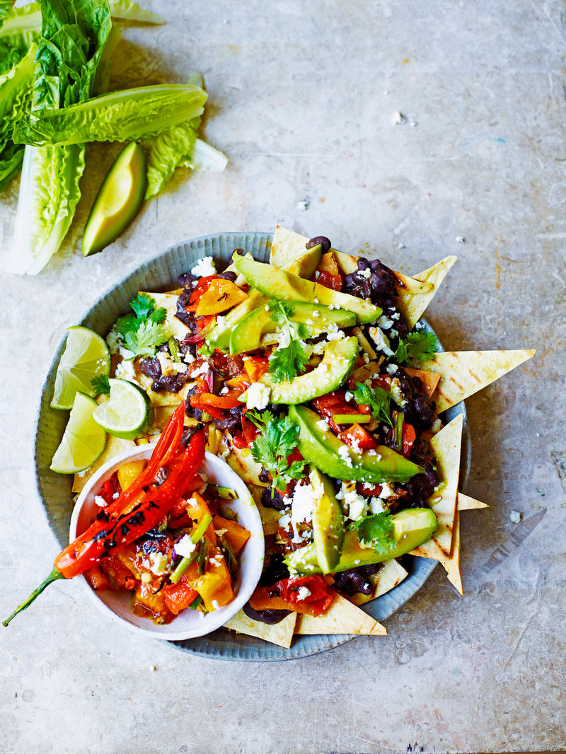

# **Meal type -Mexican Snacks**

Serves – 4 person.

Cooks in 30 minutes.

*Ingredients*

* 2 mixed-colour peppers
* 1 fresh red chilli
* 3 ripe tomatoes , on the vine
* 6 spring onions
* 1 bunch of fresh coriander
* 2 limes
* extra virgin olive oil
* 4 corn tortillas
* ½ teaspoon cumin seeds
* Chipotle Tabasco sauce
* 1 x 400g tin of black beans
* 1 ripe avocado
* 20 g feta cheese

*Method*

1. Place the oven on to 180ºC/350ºF/gas 4.
2. Place a griddle pan over a high heat and cook the whole peppers, chilli, tomatoes and trimmed spring onions until soft and charred.
3. Put the peppers and chilli in a bowl, cover with clingfilm and set aside for 5 minutes.
4. Dice the tomatoes and spring onions, then add to another bowl. Peel, deseed and dice the peppers and chillies, then add to the tomatoes and spring onions.
5. Pick in a few coriander leaves, season, then mix in a good squeeze of lime juice and a drizzle of oil. Wipe the griddle pan and return to the heat.
6. Cut the tortillas into wedges and arrange over two baking sheets. Bake in the oven for 5 minutes, or until golden.
7. Place a large frying pan over a high heat and toast the cumin seeds for a few seconds. Add the Tabasco sauce and beans and cook for a few minutes, or until thick, stirring occasionally.
8. Peel, destone and slice the avocado into wedges, then drizzle with the remaining lime juice.
9. Arrange the tortillas in a bowl. Top with the beans, salsa, dressed avocado, feta and pick over the remaining coriander, then serve.

**Country - China**

# **Boiled prawn wontons with chilli dressing**

# Boiled prawn wontons with chilli dressing

**Meal type – Starters**

Serves – 8 person.

Cooks in 40 minutes.

*Ingredients*

* 225 g raw prawns, from sustainable sources
* 1 spring onion
* 1cm piece of ginger
* 1½ teaspoon shaoxing wine or dry sherry
* 3 tablespoons light soy sauce
* ½ teaspoon white sugar
* ½ teaspoon sesame oil
* 24 fresh wonton wrappers (about 7cm square)
* SICHUAN SEASONING
* 1 tablespoon sichuan pepper
* 3 tablespoons sea salt
* CHILLI DRESSING
* 1 teaspoon dried chilli flakes
* 40 ml vegetable oil
* 20 ml light soy sauce
* 20 ml rice wine vinegar
* 1 teaspoon white sugar
* 1 pinch of sichuan seasoning

*Method*

1. First, make the sichuan seasoning. Dry-roast the sichuan pepper and 3 teaspoons of sea salt in a heavy-based pan. When the peppercorns start to pop and become aromatic, remove from the heat and allow to cool. Once cool, grind to a powder in a pestle and mortar or spice grinder.
2. Next, make the chilli dressing. Place the chilli flakes in a heatproof bowl. Heat the oil in a small heavy-based frying pan until it shimmers slightly, then carefully pour the oil over the chilli to release the heat and flavour.
3. Stir, then let stand, uncovered, for 30 minutes. Strain the oil through a fine sieve over a bowl (discard the chilli), and mix with remaining dressing ingredients.
4. For the wontons, peel, dice and place the prawn meat in a bowl. Trim and finely slice the spring onion, peel and finely slice the ginger, then add to the bowl with all the remaining ingredients, except the wonton wrappers, and mix until combined. Cover and refrigerate for 30 minutes.
5. For each wonton, place a rounded teaspoon of prawn filling in the centre of a wrapper. Dip your finger in some water and moisten the bottom edge of the wrapper, then fold it in half, towards you, to enclose the filling. Smoothing out any air, press to seal. Hold the wonton lengthways with the folded edge down. Fold in half lengthways, then lightly moisten one corner of the folded edge. Bring the two ends together with a twisting action and press lightly to seal, making a ring shape.
6. Bring a large pan of water to the boil. Carefully drop the wontons, in batches, into the water and cook for 2 minutes, or till just cooked through. To test if the wontons are ready, remove one using a slotted spoon and cut through it with a sharp knife. The prawns should be just cooked through. Remove the other wontons and drain in a colander.
7. To serve, arrange the wontons on a serving platter. Stir the chilli dressing and then spoon it over the wontons. Serve immediately, sprinkled with sichuan seasoning.

Country – Spain

Seafood paella

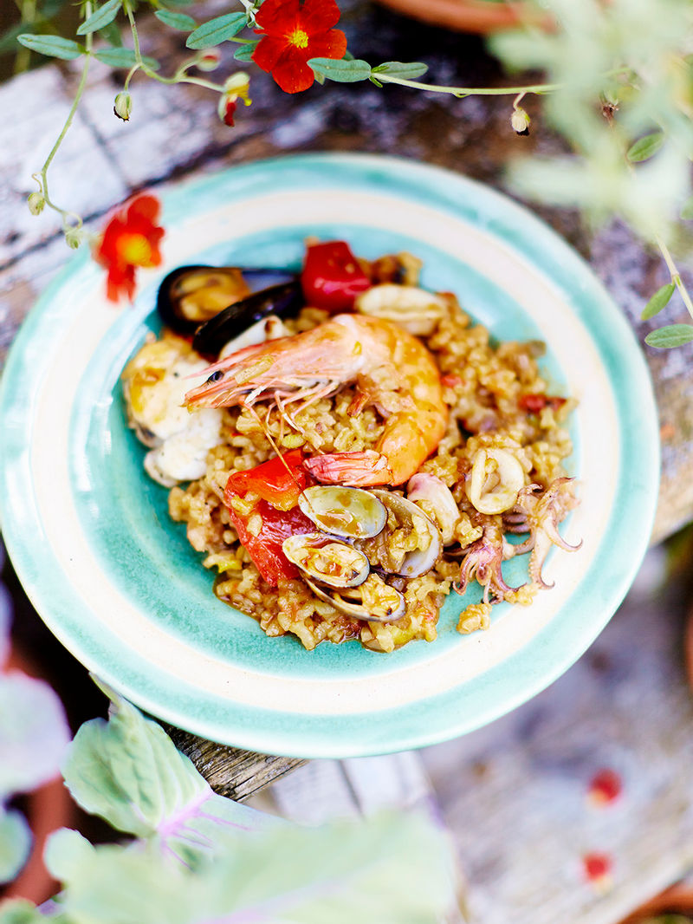

**Meal type – Dinner**

Serves – 8 person.

Cooks in 2 Hours 10 minutes

*Ingredients*

* 2 green peppers
* 2 red peppers
* 200 ml olive oil
* 750 g monkfish, from sustainable sources
* 500 g squid, cleaned, from sustainable sources
* 125 g mussels, debearded, from sustainable sources
* 125 g clams, debearded, from sustainable sources
* 1 kg calasparra or bomba paella rice
* 1 large pinch of saffron
* 1 tesapoon paprika
* 8 large prawns, from sustainable sources
* extra virgin olive oil
* PRAWN STOCK
* 1 onion
* 6 cloves of garlic
* olive oil
* 1 tablespoon paprika
* 2 fresh bay leaves
* shells and heads from 30 large prawns (ask your fishmonger for these), from sustainable sources
* 200 ml dry white wine
* 2 litres organic fish stock
* SOFRITO
* 3 large onions
* 3 cloves of garlic
* olive oil
* ½ tablespoon papriks
* 100 ml dry white wine
* 6 ripe tomatoes

*Method*

1. Start by making the stock. Peel and roughly chop the onion, then peel the garlic, keeping them whole.
2. Heat 3 tablespoons of olive oil in a large pan over a medium heat and sauté the onion, garlic, paprika, bay leaves and prawn shells and heads for 10 minutes, stirring occasionally.
3. Add the wine and fish stock and bring to the boil. Lower the heat and simmer for 30 minutes, or until it starts to reduce.
4. Strain through a colander into a large jug and set aside until needed (when you come to make the paella, just reheat the stock until hot, but not boiling).
5. For the sofrito, peel and dice the onions and garlic, then add to a large frying pan over a medium-low heat with 3 tablespoons of olive oil and the paprika. Fry for 7 to 8 minutes, or until softened and golden.
6. Pour in the wine and simmer for 1 to 2 minutes, then coarsely grate in the tomatoes, discarding the skins. Stir and cook for 5 minutes.
7. Lower the heat and simmer for another 30 minutes, or until the mixture has thickened into a lovely sauce. Transfer to a bowl until ready to use.
8. To make the paella, deseed and roughly chop the peppers. Cut the monkfish into large chunks, then slice the squid. Wash the mussels and clams thoroughly, discarding any that remain open when tapped.
9. Heat half of the olive oil in a large paella pan over a medium heat and cook the peppers for 5 minutes, until softened. Transfer to a separate bowl with a slotted spoon. Set aside.
10. Add the monkfish to the pan, season generously and cook for 10 minutes, or until tender. Set aside in a bowl.
11. Throw the squid into the pan and cook for 1 to 2 minutes, then tip it into the bowl with the monkfish. Set aside until ready to use.
12. Add the remaining oil to the pan, scatter in the rice in an even layer and sauté over a medium heat, stirring, for 5 minutes, or until the rice is golden.
13. Stir the sofrito into the rice and cook for 2 minutes, then add the hot prawn stock and bring the mixture to the boil for another 2 minutes.
14. Sprinkle the saffron and paprika over the rice, reduce the heat to low and simmer, without stirring, for 10 to 12 minutes, or until all the liquid has almost been absorbed.
15. Arrange the peppers, monkfish, squid, prawns, mussels and clams evenly around the top of the paella. Cook for about 8 minutes, turning the prawns halfway through, or until the mussels and clams have opened (discard any that don’t) and the prawns are cooked.
16. Drizzle with a little extra virgin olive oil, cover the pan with tin foil and a few clean tea towels and allow to rest for 5 minutes before serving.

# **England**

# **Strawberry & cream sandwich sponge**

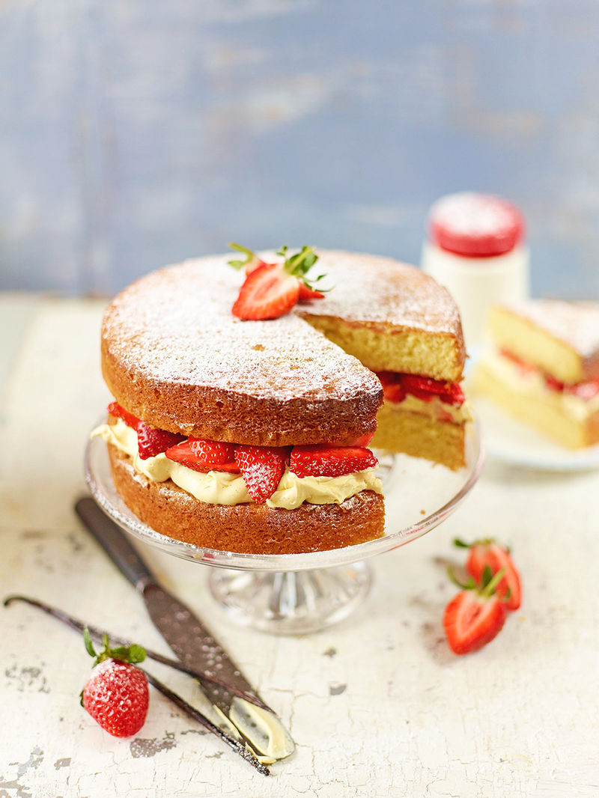

**Meal type – Snacks**

Serves – 14 person.

Cooks in 50 minutes.

*Ingredients*

* 225 g unsalted butter (at room temperature) , plus extra for greasing
* 225 g white caster sugar
* 1 teaspoon vanilla extract
* 4 large free-range eggs
* 225 g self-raising flour
* 1 teaspoon baking powder
* 1 splash of milk
* FILLING
* 200 ml double cream
* 1 vanilla pod
* 1½ tablespoon of icing sugar , plus extra for dusting
* 250 g fresh strawberries

*Method*

1. Preheat the oven to 180ºC/gas 4. Grease and line the bases of 2 round 20cm sandwich tins.
2. Cube up the butter, then cream together with the sugar in a large mixing bowl until pale and fluffy. Mix in the vanilla extract.
3. Beat the eggs, then gradually mix into the creamed butter and sugar. Sift, then fold in the flour, baking powder and ¼ of a teaspoon of sea salt with a large metal spoon until just incorporated (don’t overmix).
4. Stir in 1 splash of milk to loosen the batter, then evenly divide it between the 2 cake tins.
5. Bake the cakes in the oven for 22 to 25 minutes, or until golden and cooked through. To test, insert a skewer into the middle of a cake; it’s ready when the skewer comes out clean. Leave to cool in the tins for 5 minutes, then turn onto a wire rack to cool completely.
6. Once completely cool, pour the cream into a large bowl, scrape in the vanilla seeds and whisk until you have soft peaks.
7. Sift in icing sugar and gently fold through. Place one of the cakes on your chosen plate or cake stand and spread over the vanilla cream, but not right to the edges or it will spill later.
8. Hull and roughly slice the strawberries, then scatter on top of the second cake. Dust with icing sugar and decorate with extra strawberries, if you like.

# **Country – Italy**

# **Ravioli**

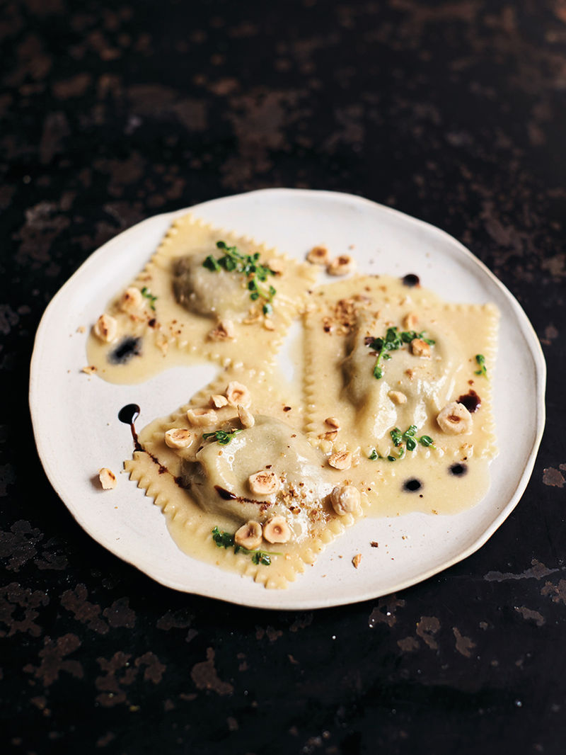

**Meal type – Lunch and Dinner**

Serves – 6 person.

Cooks in 2 hours 45 minutes.

*Ingredients*

* ¼ x [Royal pasta dough](https://www.jamieoliver.com/recipes/pasta-recipes/royal-pasta-dough/)
* fine semolina , for dusting
* FILLING
* 1 radicchio , or 2 red chicory (150g in total)
* 1 large red onion
* 80 ml balsamic vingar
* olive oil
* 1 bunch of fresh thyme , (30g)
* 300 g Maris Piper potatoes
* 50 g Parmesan cheese , plus extra to serve
* 100 g fontina cheese
* 75 g blanched hazelnuts
* 40 g unsalted butter
* extra virgin olive oil

*Method*

1. Preheat the oven to 200ºC/400ºF/gas 6.
2. Start by making the [Royal pasta dough](https://www.jamieoliver.com/recipes/pasta-recipes/royal-pasta-dough/). While it rests, make the filling.
3. Trim and quarter the radicchio, peel the onion and slice into eighths, then place in a small roasting tray. Pour over the balsamic and 2 tablespoons of olive oil, toss to coat, then strip over half the thyme leaves, reserving any pretty tips.
4. Cover with a sheet of wet scrunched-up greaseproof paper and roast for 1 hour.
5. Prick the potatoes and dry-roast in a separate tray alongside until cooked through, then remove. Once cool enough to handle, scoop the potatoes out of their skins and mash the insides in a bowl.
6. Finely chop the radicchio and onion, then stir into the potato with 1 tablespoon of the balsamic juices from the tray. Finely grate in most of the Parmesan and all the fontina, mix well, then season to perfection with sea salt and black pepper. Leave to cool completely.
7. On a clean flour-dusted surface, roll out the pasta dough so it’s 1mm thick and roughly 16cm wide (the width of a standard pasta machine).
8. Spoon heaped teaspoons of filling evenly down the pasta strips, slightly off centre, leaving a 5cm gap between each. Brush the exposed pasta lightly with water and fold the sheets in half over the filling.
9. Gently seal around the filling, pushing out the air – you can cut them into 8cm circles with a pastry cutter or into squares with a knife. Place them on a semolina-dusted tray as you go – you’ll get about 18 ravioli in total.
10. Toast the hazelnuts in a large frying pan on a medium heat until golden, then lightly bash and tip into a bowl.
11. Cook the ravioli two portions at a time in a pan of boiling salted water for 3 to 4 minutes.
12. Meanwhile, place the frying pan back on a low heat and add a splash of olive oil, a third of the butter, and a third of the remaining thyme leaves and tips. Fry until golden, then remove from the heat.
13. Scoop the pasta straight into the buttery sauce, bringing some starchy cooking water with it, add a fine grating of Parmesan, toss gently, then spoon on to warmed plates.
14. Finish each portion with a scattering of hazelnuts, a little extra virgin olive oil, some extra Parmesan and a few small drips of the balsamic juices, if you like. Serve up to your first lucky guests, while you crack on with the next two portions.

# **Country – Morocco**

# **Orlando Bloom's lamb shank tagine**

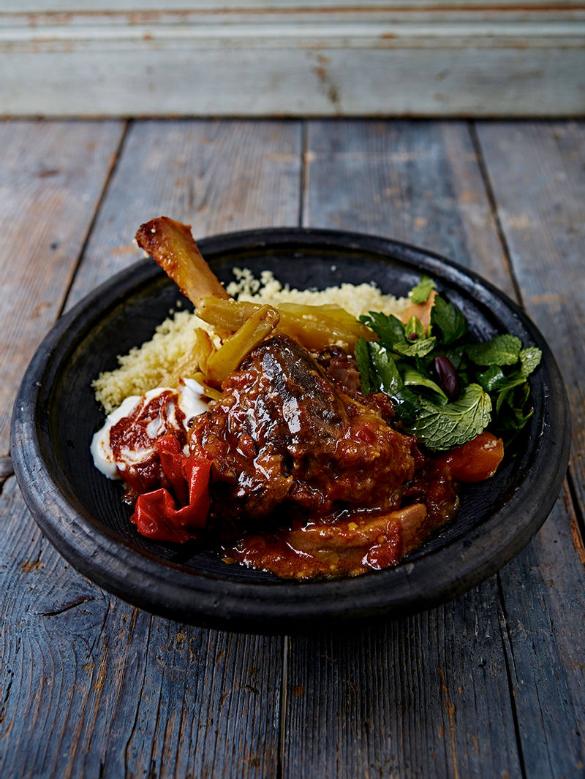

**Meal type – Lunch and Dinner**

Serves – 4 person.

Cooks in 3 hours 20 minutes.

*ngredients*

* 4 lamb shanks , French trimmed
* olive oil
* 1 fresh red chilli
* 1 clove of garlic
* 1 red onion
* 1 quince
* 2 carrots
* 1 bulb of fennel
* 2 fresh bay leaves
* 1 pinch of saffron
* 2 ripe tomatoes , on the vine
* 1 preserved lemon
* 1 litre quality organic chicken stock
* 200 g couscous
* 1 bunch of fresh mint , (30g)
* 1 handful of black olives , (stone in)
* ½ a bunch of fresh flat-leaf parsley , (15g)
* ½ a lemon
* ½ an orange
* extra virgin olive oil
* 50 g rose harissa
* 4 heaped tablespoons fat-free natural yoghurt
* RAS EL-HANOUT
* 2 cardamon pods
* ½ teaspoon ground cinnamon
* 1 teaspoon cayenne pepper
* 1 heaped teaspoon coriander seeds
* ½ teaspoon sweet smoked paprika
* 1 tiny pinch of cumin seeds
* ½ teaspoon ground turmeric
* ½ teaspoon ground ginger

*Method*

1. Preheat the oven to 160ºC/325ºF/gas 3.
2. To make the ras el hanout, lightly bash the cardamom pods in a pestle and mortar, then shake out the seeds, discarding the pods. Bash and muddle in the remaining ingredients to form a powder.
3. Massage into the lamb shanks, then place in a large ovenproof pan on a medium-high heat with ½ a tablespoon of olive oil. Cook for 6 to 8 minutes, or until browned all over, turning regularly.
4. Prick the chilli and add alongside the lamb until slightly scalded all over, then remove both lamb and chilli to a plate.
5. Peel and finely slice the garlic. Peel the onion and quince, cutting each into 8 wedges. Peel the carrots and chop at an angle into 4cm chunks. Trim and quarter the fennel bulb.
6. Wipe out the pan with a ball of kitchen paper, then place on a medium heat with ½ a tablespoon of olive oil, the pricked chilli, bay leaves, garlic, quince and veg. Cook for 10 to 12 minutes, or until softened, stirring occasionally.
7. In a cup, just cover the saffron with boiling water.
8. Return the lamb shanks to the pan, then quarter and add the tomatoes along with the saffron mixture, whole preserved lemon and stock. Bring to the boil. Cover the surface with a scrunched-up circular sheet of wet greaseproof paper, then pop a lid on.
9. Cook in the oven for 2 hours to 2 hours 30 minutes, or until the shanks are soft and delicious and the sauce has reduced.
10. Use a spoon to skim away any excess fat from the surface, then carefully remove the shanks to a plate.
11. Place the pan on a medium-high heat for 5 to 10 minutes, or until the sauce has thickened and reduced, stirring occasionally.
12. Place the couscous and half the mint sprigs in a bowl, just cover with boiling water, pop a plate on top and leave to soak and infuse.
13. To make a salad, destone the olives and roughly tear into a bowl. Pick in the parsley and remaining mint leaves, squeeze over the lemon and orange juice, add a drizzle of extra virgin olive oil and a pinch of sea salt and black pepper, then toss together.
14. Swirl the harissa through the yoghurt. Return the lamb shanks to the sauce.
15. Fluff up the couscous, discarding the mint, then divide between your plates. Spoon over the tagine, sprinkle over the salad, and finish with a dollop of harissa yoghurt.

# **Country – Peru**

# **Peruvian ceviche**

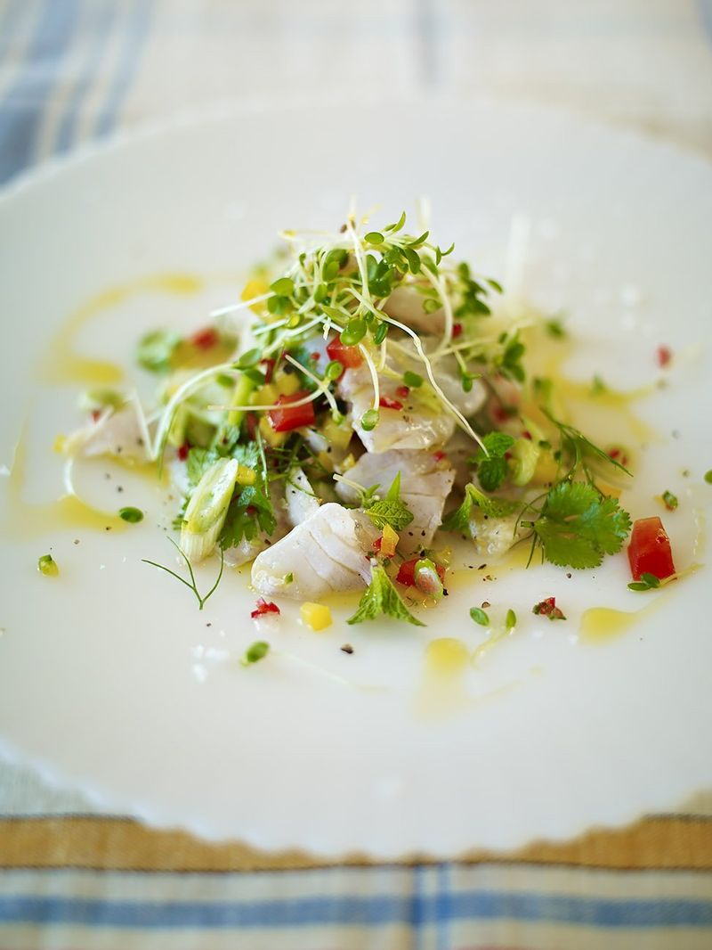

**Meal type – Lunch and Dinner**

Serves – 4 person.

Cooks in 20 minutes.

*Ingredients*

* 1 red or yellow pepper
* 2 spring onions
* 400 g skinless sea bass, lemon sole or snapper , pinboned, from sustainable sources
* juice of 3 lemons
* 1-2 fresh red chillies
* 8 sprigs of fresh mint
* 8 sprigs of fresh coriander
* 1 punnet of mustard cress
* a few fennel tops , (optional)
* extra virgin olive oil

*Method*

1. Deseed and very finely chop the pepper, and trim and finely slice the spring onions, then add to a bowl.
2. Slice the fish into 1cm cubes, add to the bowl, then cover and place in the fridge until needed.
3. Squeeze the lemon juice into a jam jar, add 1 teaspoon of sea salt, then seseed, finely chop and add the chilli.
4. Pop the lid on and place in the fridge to chill – this may seem like a lot of salt but most of it gets drained away. Pick the herbs and cress, and place in the fridge.
5. You can assemble the ceviche just before your guests are ready to eat, but it’s important that you don’t leave the fish marinating for too long – you don’t want the acids in the juices to cook the fish. Pour the lemon dressing over the fish mixture and immediately mix it up. Leave it to sit for about 2½ minutes while you lay out the plates.
6. Throw most of the herb mixture into the bowl with the fish and very quickly toss it together – no more than 10 seconds.
7. Divide the ceviche between 4 plates, gently spoon over a little of the dressing (discarding the rest) and sprinkle with the remaining herbs.
8. Drizzle over a little oil from a height, sprinkle with freshly ground black pepper, and enjoy.

# **Country – India**

# **Plantain dosa**

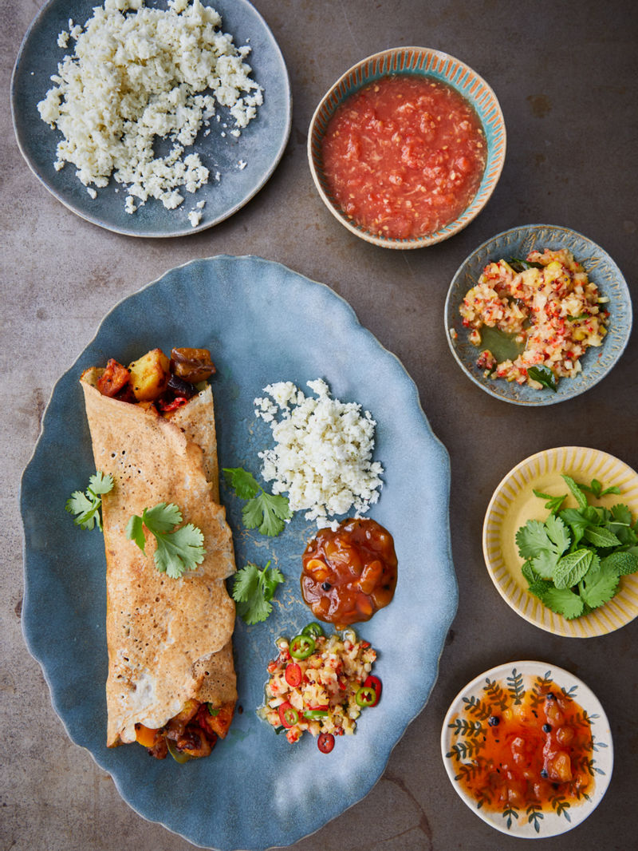

**Meal type – Lunch and Dinner**

Serves – 4 person.

Cooks in 1 hours 30 minutes.

*Ingredients*

* 3 red onions
* 500 g Maris Piper potatoes
* 1 plantain
* 500 g squash or pumpkin
* 10 cm piece of ginger
* 2 fresh red chillies
* coconut oil
* 1 teaspoon mustard seeds
* 1 teaspoon fenugreek seeds
* 10 fresh curry leaves
* ½ teaspoon turmeric
* 6 sprigs of fresh coriander , to serve
* mango chutney , to serve
* BATTER
* 150 g urid dal
* 300 g rice , (I used sona masoori)
* 1 tablespoon fenugreek seeds
* TOMATO CHUTNEY
* 2 ripe tomatoes
* ¼ white onion
* 5 cm piece of ginger
* 1 fresh red chilli
* 1 lime
* COCONUT CHUTNEY
* 1 fresh coconut
* 1 lime
* ¼ white onion
* 3 cm piece of ginger
* LEMON PICKLE
* 1 lemon
* 1 fresh red chilli
* vegetable oil
* 1 pinch of cumin seeds
* 1 teaspoon black mustard seeds
* 6 fresh curry leaves

*Method*

1. To make the dosa batter, wash the dal and rice thoroughly, then drain and soak in 900ml of fresh water with the fenugreek seeds, covered, for 6-12 hours or until the grains have swelled and softened.
2. Tip the mixture into a blender and whiz until smooth, then transfer to a non-metallic bowl. Cover and set aside overnight, or until the mixture is frothy, light and full of volume.
3. Once the batter has fermented and you’re ready to get started, preheat the oven to 180°C/350°F/gas 4.
4. To make the filling, peel and roughly slice the onions, scrub and roughly chop the potatoes, peel and chop the plantain and squash. Peel the ginger and finely slice. Finely slice the chillies into rounds.
5. Place a large baking tray directly on the hob over a medium heat. Add 1 tablespoon of coconut oil, the mustard seeds, fenugreek seeds and curry leaves, and cook for 2 minutes or until sizzling. Add the onions, chilli and ginger, stirring to coat in the spices.
6. Add the potatoes, squash and plantain, followed by the tumeric. Give it a good stir and place in the hot oven for 1 hour or until the vegetables are golden and soft. Once cooked, smash it all up ready for filling your dosa.
7. Meanwhile, prepare your chutneys and pickle. For the tomato chutney, halve the tomatoes, then coarsely grate into a bowl, discarding the skins. Peel the onion and ginger and finely grate into bowl with the chilli. Squeeze in the lime juice and season to taste with sea salt and black pepper.
8. For the coconut chutney, crack open the coconut and scrape out the flesh with a fork (or coarsely grate) into a bowl. Finely grate in the lime zest and squeeze in all the juice. Peel and finely grate in the onion and ginger, then season to taste.
9. For the lemon pickle, quarter the lemon, discard the seeds, and finely chop. Finely chop the chilli (seeds and all). Place a small frying pan on medium heat with 1 tablespoon of vegetable oil. Add the cumin and mustard seeds, wait for them to pop, then go in with the curry leaves, lemon and chilli. Cook for 30 seconds, stirring constantly, then season to taste and pop into a little serving bowl. Leave to cool.
10. To cook your dosa, one at a time, place a large non-stick frying pan on a medium heat and grease with a little vegetable oil. Season your batter with sea salt and give it a good whisk. Add a ladleful of batter to the pan, using the back of the ladle to swirl it around getting it as thin as possible. Cook for 5 minutes or until the underside is golden and crisp. Drizzle a teaspoon of vegetable oil over the surface of the dosa (no need to flip it) and cook for 1-2 minutes more.
11. Load up your dosa with the spicy veggie filling, roll it up like a cigar and keep warm in the oven while you cook up the rest of the dosa. Repeat with the remaining batter.
12. Garnish the dosas with a sprig of coriander and serve with the chutneys for dipping. Delicious!

# **Country – America**

# **Lime pie**

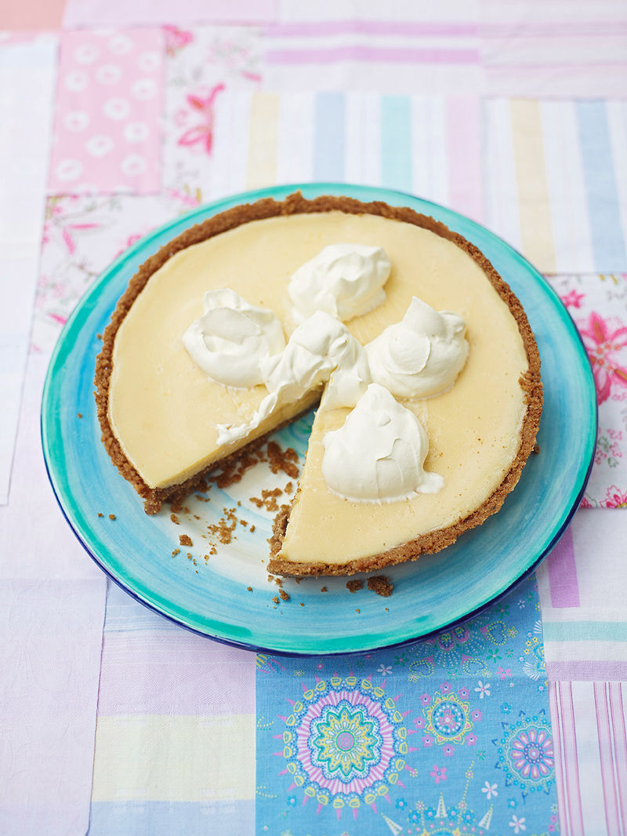

**Meal type – Dessert**

Serves – 10 person.

Cooks in 45 minutes

*Ingredients*

* 4 large free-range egg yolks
* 400 ml condensed milk
* 5 limes
* 200 ml double cream
* CRUST
* 135 g unsalted butter
* 12 digestive biscuits
* 45 g caster sugar

*Method*

1. Preheat the oven to 175ºC/gas 3. Lightly grease a 22cm metal or glass pie dish with a little of the butter.
2. For the pie crust, blend the biscuits, sugar and remaining butter in a food processor until the mixture resembles breadcrumbs.
3. Transfer to the pie dish and spread over the bottom and up the sides, firmly pressing down.
4. Bake for 10 minutes, or until lightly browned. Remove from oven and place the dish on a wire rack to cool.
5. For the filling, whisk the egg yolks in a bowl. Gradually whisk in the condensed milk until smooth.
6. Mix in 6 tablespoons of lime juice, then pour the filling into the pie crust and level over with the back of a spoon.
7. Return to the oven for 15 minutes, then place on a wire rack to cool.
8. Once cooled, refrigerate for 6 hours or overnight.
9. To serve, whip the cream until it just holds stiff peaks. Add dollops of cream to the top of the pie, and grate over some lime zest, for extra zing if you like.

# **Country – Greek**

# **Horiatiki salad**

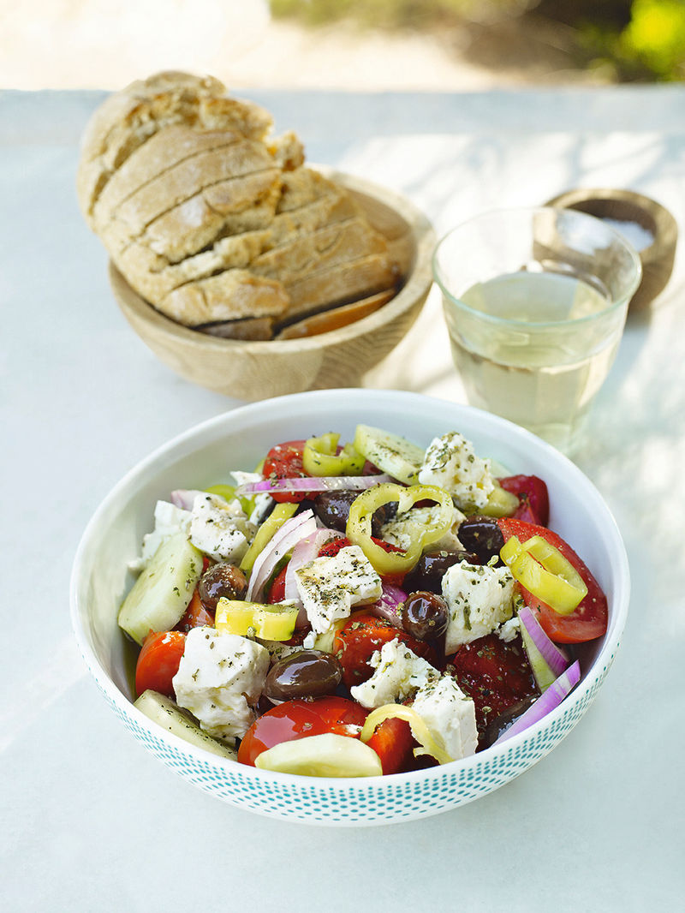

**Meal type – Starters**

Serves – 4 person.

Cooks in 10 minutes

*Ingredients*

* 125 g greek feta
* 2 green peppers
* 1 cucumber
* 1 small red onion
* 5 ripe tomatoes
* 1 handful of kalamata olives
* 1 tesapoon dried oregano
* 3-4 tablespoons extra virgin olive oil
* 3-4 tablespoons red wine vinegar

*Ingredients*

* 125 g greek feta
* 2 green peppers
* 1 cucumber
* 1 small red onion
* 5 ripe tomatoes
* 1 handful of kalamata olives
* 1 tesapoon dried oregano
* 3-4 tablespoons extra virgin olive oil
* 3-4 tablespoons red wine vinegar